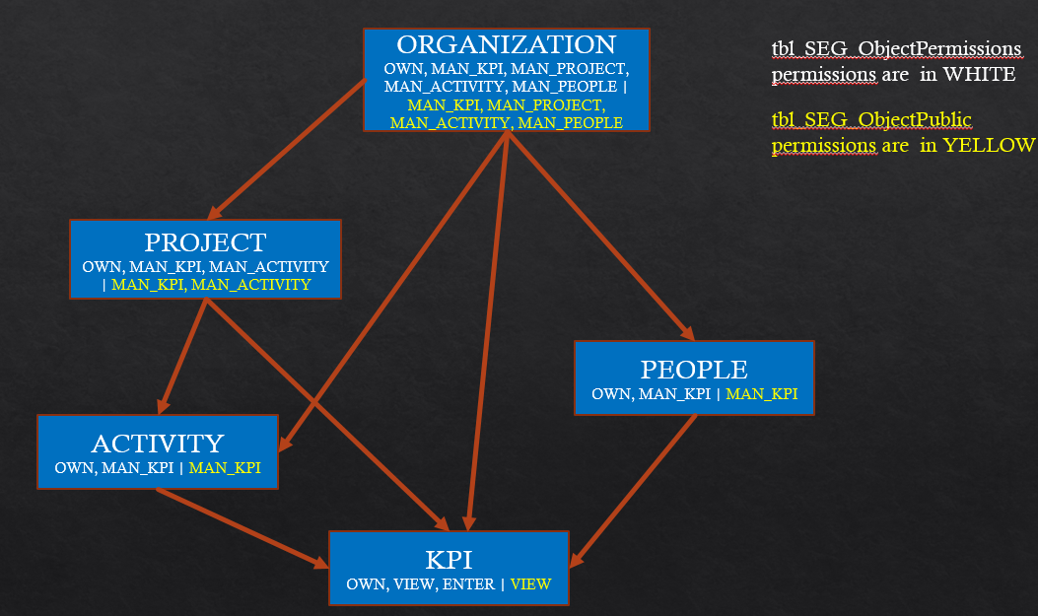

For the following description ORG = ORGANIZATION, ACT = ACTIVITY, PPL = PEOPLE, PROF = PROJECT.

If we need to determine the list of KPIs that a specific user can see we need to follow the following steps:

1. Search for all ORGs where the user has OWN permissions and all to the list of KPIs all of those KPIs associated to those ORGs.
2. Search for all ORGs where the user has MAN_KPI permissions or ORG has public MAN_KPI and add to the list of KPIs all of these that are directly associated to the organization and ARE NOT associated to a PROJ, ACT or PPL.
3. Search for all ORGs where the user has MAN_PROJECT permissions or ORG has public MAN_PROJECT, then search for all PROJs associated to these ORGs and then add to the KPI list all of the KPIs that are associated to these PROJs.
4. For the list of projects obtained above, search for all the ACT that are associated to these PROJ and then add to the KPI list all of the KPIs that are associated to these ACT.
5. Search for all ORGs where the user has MAN_ACTITIVIES permissions or ORG has public MAN_ACTITIVIES and search for ACT that are associated to these ORGs and ARE NOT associated to any PROJ, then add to the KPI list all of the KPIs that are associated to these ACT.
6. Search for all ORGs where the user has MAN_PEOPLE permissions or where the ORG has public MAN_PEOPLE, then search for all of the PPL that are associated to those ORGs and finally add to the KPI list all of the KPIs that are associated to those PPL.
7. Search for all ACT where the user has OWN or MAN_KPI permissions or the ACT is public MAN_KPI and add to the KPI list all of the KPIs that are associated to the ACT.
8. Search for all PROJ where the user has OWN or MAN_KPI permissions, or where the ORG is public MAN_KPI and add to the KPI list all of the PKIs that are associated to those PROJ.
9. Search for all PROJ where the user has MAN_ACTIVITIES permissions or where the PROJ is public MAN_ACTIVITIES, then search for all of the ACT that are associated to these PROJs and finally add to the KPI list the KPIs that are associated to these ACT.
10. Search for all PPL where the user has OWN or MAN_KPI permissions or where the PPL is public MAN_KPI and add to the KPI list all of the KIPs that are associated to these PPL.
11. Add to the KPI list all of the KPIs that are public VIEW_KPI
12. Add to the KPI list all of the KPIs where the user has OWN or VIEW_KPI or ENTER_DATA permissions.

At the end of this, we should have a list of all of the KPIs that the user can see.